**1. Write a blog on Difference between HTTP1.1 vs HTTP2**

HTTP stands for HyperText Transfer Protocol, and it is the basis for almost all web applications. More specifically, HTTP is the method computers and servers use to request and send information.

By using HTTP user sends the request to the server & the server sends the response to the user. There are several stages of development of HTTP but we will focus mainly on HTTP/1.1 which was created in 1997 & the new one is HTTP/2 which was created in 2015.

**What is HTTP/1.1?**

The first usable version of HTTP was created in 1997. Because it went through several stages of development, this first version of HTTP was called HTTP/1.1. This version is still in use on the web.

**What is HTTP/2?**

In 2015, a new version of HTTP called HTTP/2 was created. HTTP/2 solves several problems that the creators of HTTP/1.1 did not anticipate. In particular, HTTP/2 is much faster and more efficient than HTTP/1.1. One of the ways in which HTTP/2 is faster is in how it prioritizes content during the loading process.

**What are the differences between HTTP/2 and HTTP/1.1 ?**

**Multiplexing:** HTTP/1.1 loads resources one after the other, so if one resource cannot be loaded, it blocks all the other resources behind it. In contrast, HTTP/2 is able to use a single [TCP](https://www.cloudflare.com/learning/ddos/glossary/tcp-ip/) connection to send multiple streams of data at once so that no one resource blocks any other resource. HTTP/2 does this by splitting data into binary-code messages and numbering these messages so that the client knows which stream each binary message belongs to.

**Server push:** Typically, a server only serves content to a client device if the client asks for it. However, this approach is not always practical for modern webpages, which often involve several dozen separate resources that the client must request. HTTP/2 solves this problem by allowing a server to "push" content to a client before the client asks for it. The server also sends a message letting the client know what pushed content to expect – like if Bob had sent Alice a Table of Contents of his novel before sending the whole thing.

**Header compression:** Small files load more quickly than large ones. To speed up web performance, both HTTP/1.1 and HTTP/2 compress HTTP messages to make them smaller. However, HTTP/2 uses a more advanced compression method called HPACK that eliminates redundant information in HTTP header packets. This eliminates a few bytes from every HTTP packet. Given the volume of HTTP packets involved in loading even a single webpage, those bytes add up quickly, resulting in faster loading.

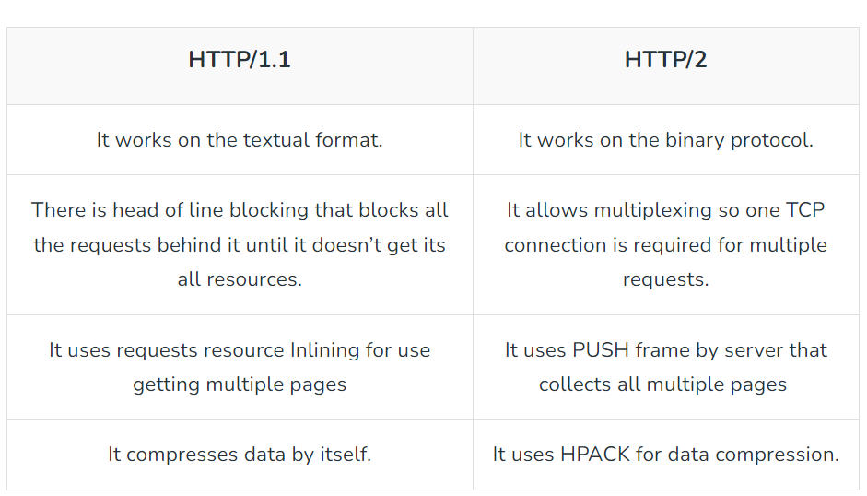

**2. Write a blog about objects and its internal representation in JavaScript**

Objects, in JavaScript, is it’s most important data-type and forms the building blocks for modern JavaScript.

These objects are quite different from JavaScript’s primitive data-types (Number, String, Boolean, null, undefined and symbol) in the sense that while these primitive data-types all store a single value each (depending on their types).

Objects are more complex and each object may contain any combination of these primitive data-types as well as reference data-types.  
An object, is a reference data type.

Variables that are assigned a reference value are given a reference or a pointer to that value.

That reference or pointer points to the location in memory where the object is stored. The variables don’t actually store the value.

Objects in JavaScript may be defined as an unordered collection of related data, of primitive or reference types, in the form of “key: value” pairs. These keys can be variables or functions and are called properties and methods, respectively, in the context of an object.

**Objects and properties**

A JavaScript object has properties associated with it. A property of an object can be explained as a variable that is attached to the object.

Object properties are basically the same as ordinary JavaScript variables, except for the attachment to objects. The properties of an object define the characteristics of the object. You access the properties of an object with a simple dot-notation:  
**Ex : objectName.propertyName**

Like all JavaScript variables, both the object name (which could be a normal variable) and property name are case sensitive. You can define a property by assigning it a value. For example, let’s create an object named myCar and give it properties named make, model, and year as follows:

var myCar = new Object();  
myCar.make = 'Ford';  
myCar.model = 'Mustang';  
myCar.year = 1969;

Unassigned properties of an object are [undefined](https://developer.mozilla.org/en-US/docs/Web/JavaScript/Reference/Global_Objects/undefined) (and not [null](https://developer.mozilla.org/en-US/docs/Web/JavaScript/Reference/Global_Objects/null)).

myCar.color; // undefined

Properties of JavaScript objects can also be accessed or set using a bracket notation (for more details see [property accessors](https://developer.mozilla.org/en-US/docs/Web/JavaScript/Reference/Operators/Property_Accessors)). Objects are sometimes called *associative arrays*, since each property is associated with a string value that can be used to access it. So, for example, you could access the properties of the myCar object as follows:

myCar['make'] = 'Ford';  
myCar['model'] = 'Mustang';  
myCar['year'] = 1969;

An object property name can be any valid JavaScript string, or anything that can be converted to a string, including the empty string. However, any property name that is not a valid JavaScript identifier (for example, a property name that has a space or a hyphen, or that starts with a number) can only be accessed using the square bracket notation. This notation is also very useful when property names are to be dynamically determined (when the property name is not determined until runtime). Examples are as follows:

// four variables are created and assigned in a single go,   
// separated by commas  
var myObj = new Object(),  
 str = 'myString',  
 rand = Math.random(),  
 obj = new Object();  
myObj.type = 'Dot syntax';  
myObj['date created'] = 'String with space';  
myObj[str] = 'String value';  
myObj[rand] = 'Random Number';  
myObj[obj] = 'Object';  
myObj[''] = 'Even an empty string';console.log(myObj);

You can also access properties by using a string value that is stored in a variable:

var propertyName = 'make';  
myCar[propertyName] = 'Ford';propertyName = 'model';  
myCar[propertyName] = 'Mustang';

You can use the bracket notation with [for...in](https://developer.mozilla.org/en-US/docs/Web/JavaScript/Reference/Statements/for...in) to iterate over all the enumerable properties of an object. To illustrate how this works, the following function displays the properties of the object when you pass the object and the object's name as arguments to the function:

function showProps(obj, objName) {  
 var result = ``;  
 for (var i in obj) {  
 // obj.hasOwnProperty() is used to filter out properties from the object's prototype chain  
 if (obj.hasOwnProperty(i)) {  
 result += `${objName}.${i} = ${obj[i]}\n`;  
 }  
 }  
 return result;  
}

So, the function call showProps(myCar, "myCar") would return the following:

myCar.make = Ford  
myCar.model = Mustang  
myCar.year = 1969